Week #2 – Dailies
Monday:
Vocabulary list #1
Devise (v) – to plan
Kinsmen (n) – a relative either by blood or marriage
Mutiny (n)– rebellion against authority
Quarrel (v) – to fight
Vile (adj) – disgusting; repulsive
Tuesday:
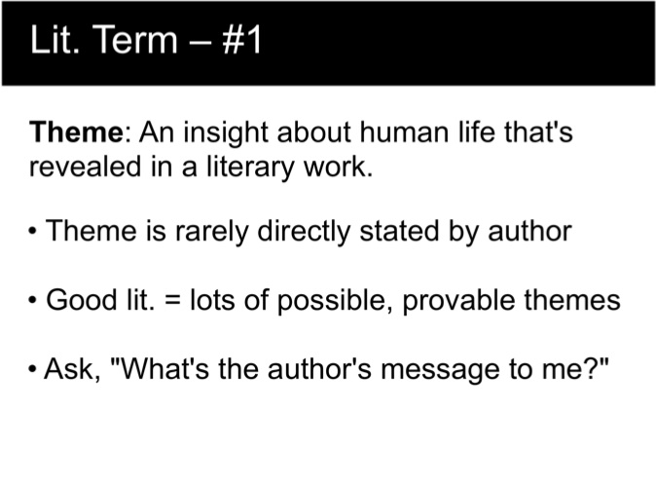
Wednesday:
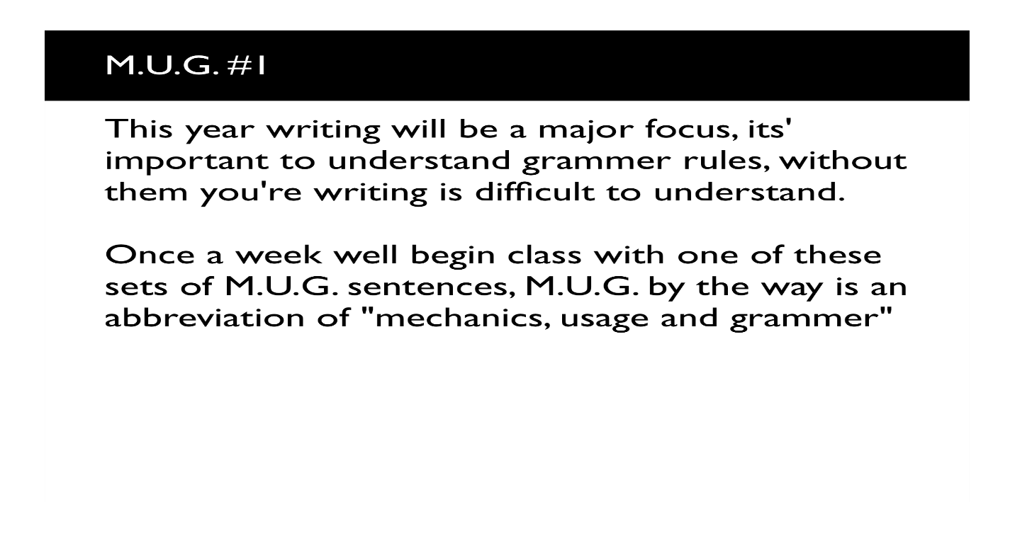
Thursday:
RC #1- The Lure of Shakespeare

Friday:
Journal prompt #2
Hold your hands out in front of you, palms down. Imagine that you have a total of five strings tied around your fingers. Write one paragraph about the objects that are dangling from the strings. Make sure that your paragraph contains a hook, topic sentence, three supporting details and a conclusion sentence.

