Book Advertisement Project
Name: ________________________________ Date: _______________________ DUE: ________________________
Yes! I want you to read for your own pleasure and enjoyment. So, be sure to take advantage of the opportunity to pick something that YOU are interested in reading. If you don’t pick something that you are interested in reading, then Independent Reading will be a dragggg.
Even though you are reading for pleasure, I still need to measure your reading in my class. Thus, to prove that you have read, you are required to create a poster advertisement based on the book you have read. Imagine your book is being made into a movie and you are in charge of advertising! You will be graded on your creativity, attention to detail, as well as the information that you provide. You poster will be placed in a gallery walk, you do NOT need to present to the class.
Requirements/Rubric:
- Must be on a poster or butcher paper that is BIGGER than 8 ½ x 11:………………………………. ____________/10 pts.
- On the poster, creatively place the following:………………………………………………………………….. ____________/10 pts.
  - the title of your book
  - Author’s name
  - Your name as “Produced by…”
- Assemble a picture collage that represents the plot and story; at least 5 pictures: …………____________/15 pts.
- Use an important quote from the story (Use quotation marks): ………………………………………____________/10 pts.
- Give your rating out of 5 stars: …………………………………………………………………………………………____________/5 pts.
- Give a brief synopsis of the book without spoiling the ending, make sure you discuss the setting, the main character, the conflict, and the point of view: …………………………………………………………………__.__________/25 pts.
- Give a brief paragraph explaining what you liked about your book: explain why you liked the characters or the story: ……………………………………………………………………………………………………………………………____________/25 pts.

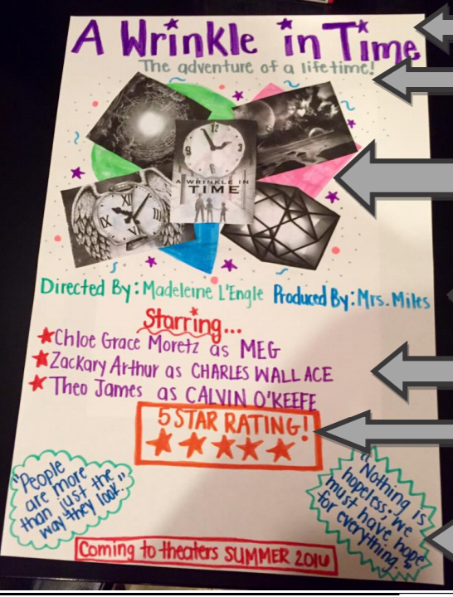
Guide to writing:

Title:___________________________

Author’s name: _______________________________

Rating:

Synopsis (a.k.a. Summary):
_______________________________________________

_______________________________________________

_______________________________________________

_______________________________________________

_______________________________________________

_______________________________________________

_______________________________________________

_______________________________________________

_______________________________________________

_________________________________________________________________________________________________

_________________________________________________________________________________________________
Review: Give your review of the book using 3rd persion. Do not use “I believe” or “I think”. For example, Do NOT say, “I believe the book would be a great choice for young readers. DO say, “This book is an excellent choice for young readers.” Talk about if you liked the characters’ personalities, plot, how it is written,
_________________________________________________________________________________________________

_________________________________________________________________________________________________

_________________________________________________________________________________________________

_________________________________________________________________________________________________

_________________________________________________________________________________________________

_________________________________________________________________________________________________

_________________________________________________________________________________________________

_________________________________________________________________________________________________

_________________________________________________________________________________________________

